**CA3001 – Programming and Data Structures using C**

**Assignment 1 : 21.12.2020**

**Q1**. Find a student average mark given mark1 and mark2.

Ans – Algorithm & Flowchart

Step 1: Start

Step 2: Declare variables mark1, mark2, Average

Step 3: Read variables mark1, mark2

Step 4: Average = (mark1 + mark2)/2

Step 5: Display Average

Step 6: Stop

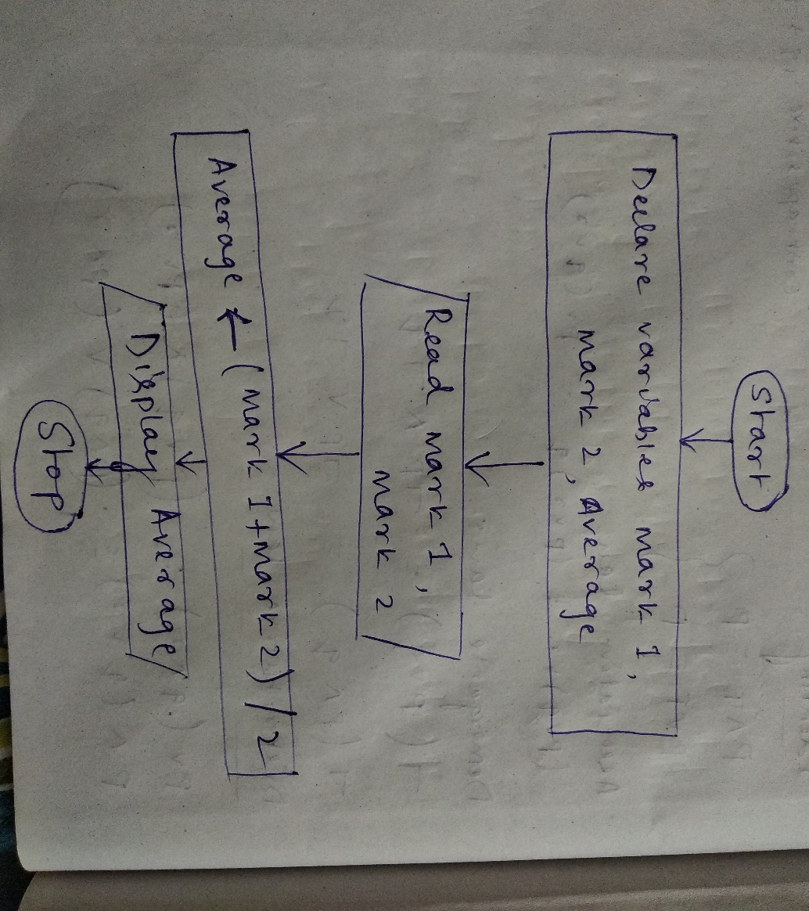

**Q2**. Calculate the total fine charged by library for late-return books. The charge is 0.20 INR for 1 day.

Ans – Algorithm & flowchart

Step 1: Start

Step 2: Declare variables fine, charge, days

Step 3: Input charge = 0.20, days = 5

Step 4: fine = charge * days

Step 5: Display fine

Step 6: Stop

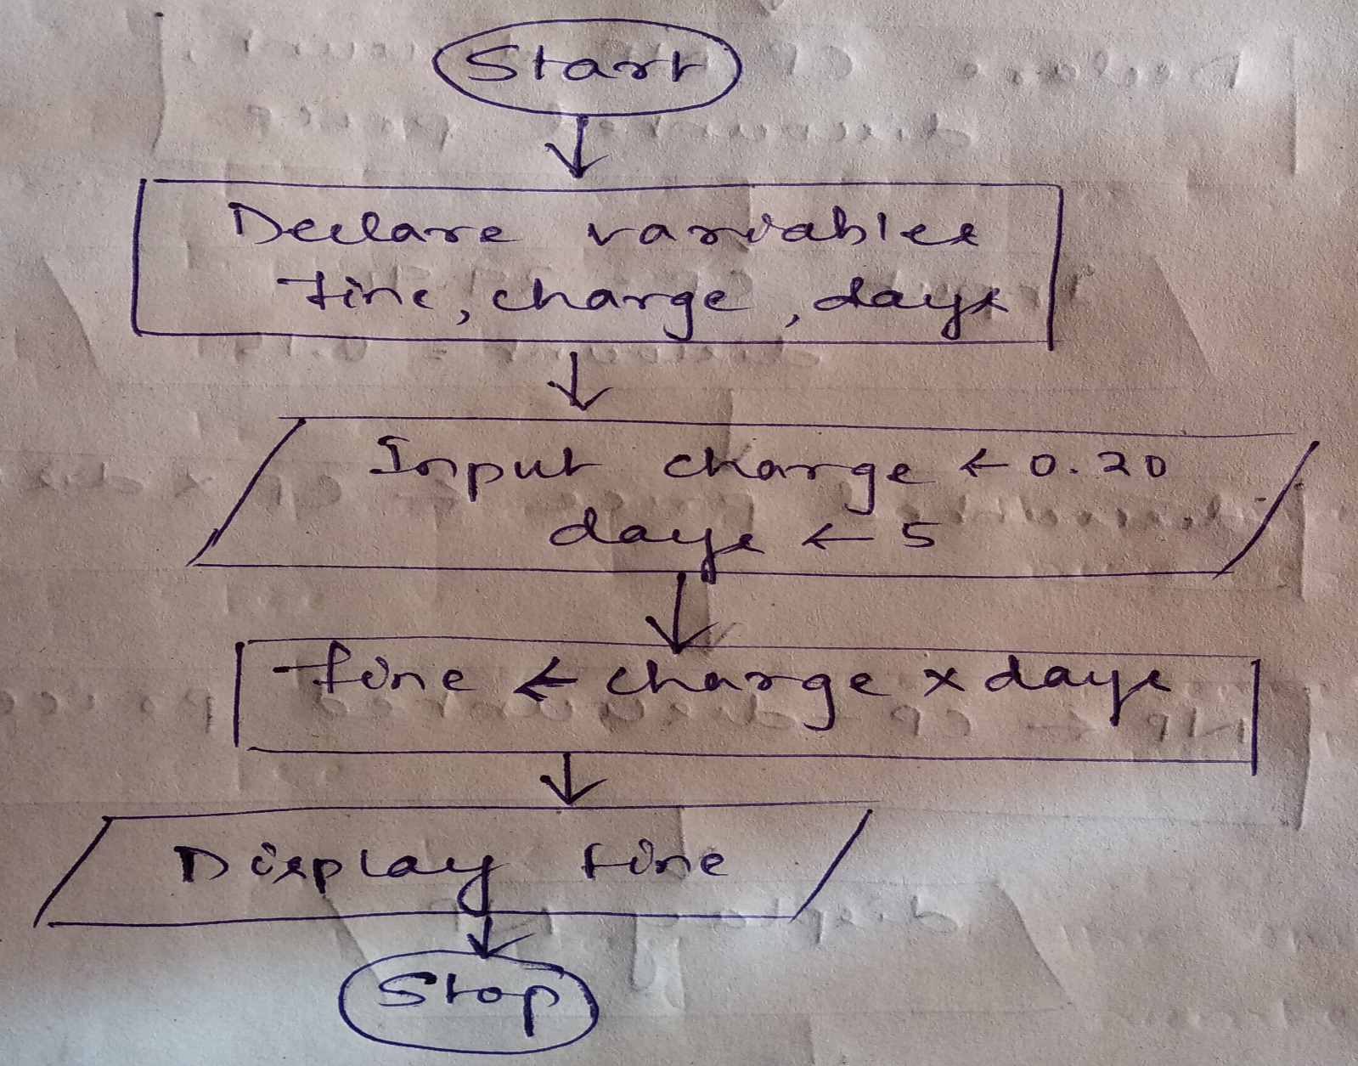

**Q3**. You had bought a nice shirt which cost Rs.29.90 with 15% discount. Count the nett price for the shirt.

Ans - Algorithm and flowchart

Step 1: Start

Step 2: Declare CP, NP, discount, discounted price

Step 3: Input CP = 29.90, discount = 0.15

Step 4: discounted price = CP * discount

NP = CP - discounted price

Step 5: display NP

Step 6: Stop

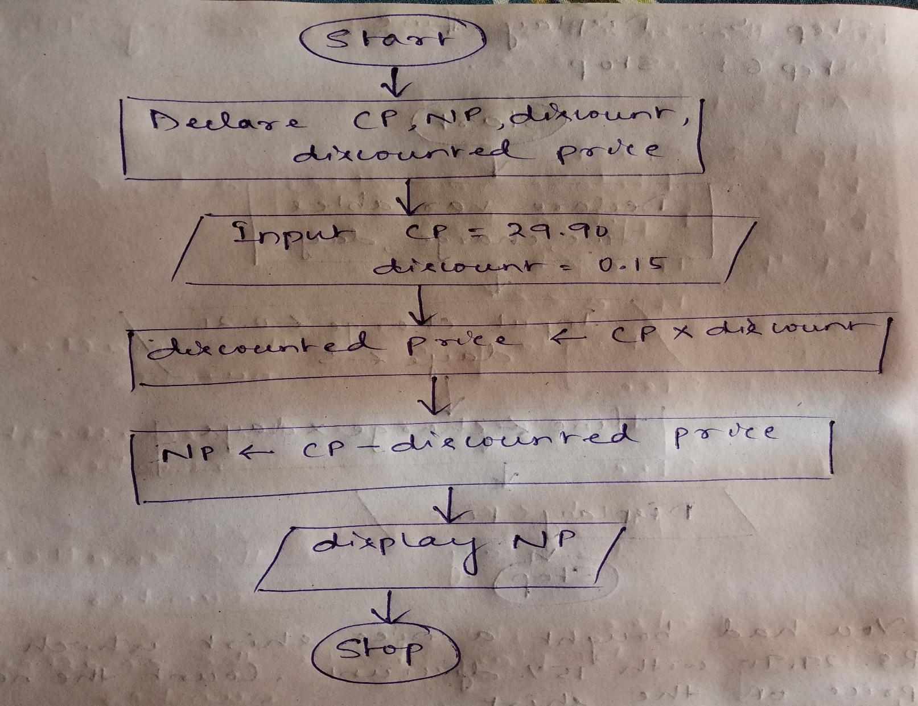

**Q4**. Find the smallest number among three different numbers.

Ans - Algorithm & flowchart

Step 1: Start

Step 2: Declare variable a, b, c

Step 3: Input a, b, c

Step 4: If a<b

If a<c

Display a is the smallest number

Else

Display c is the smallest number

Else

If b<c

Display c is the smallest number

Else

Display b is the smallest number

Stop 5: Stop

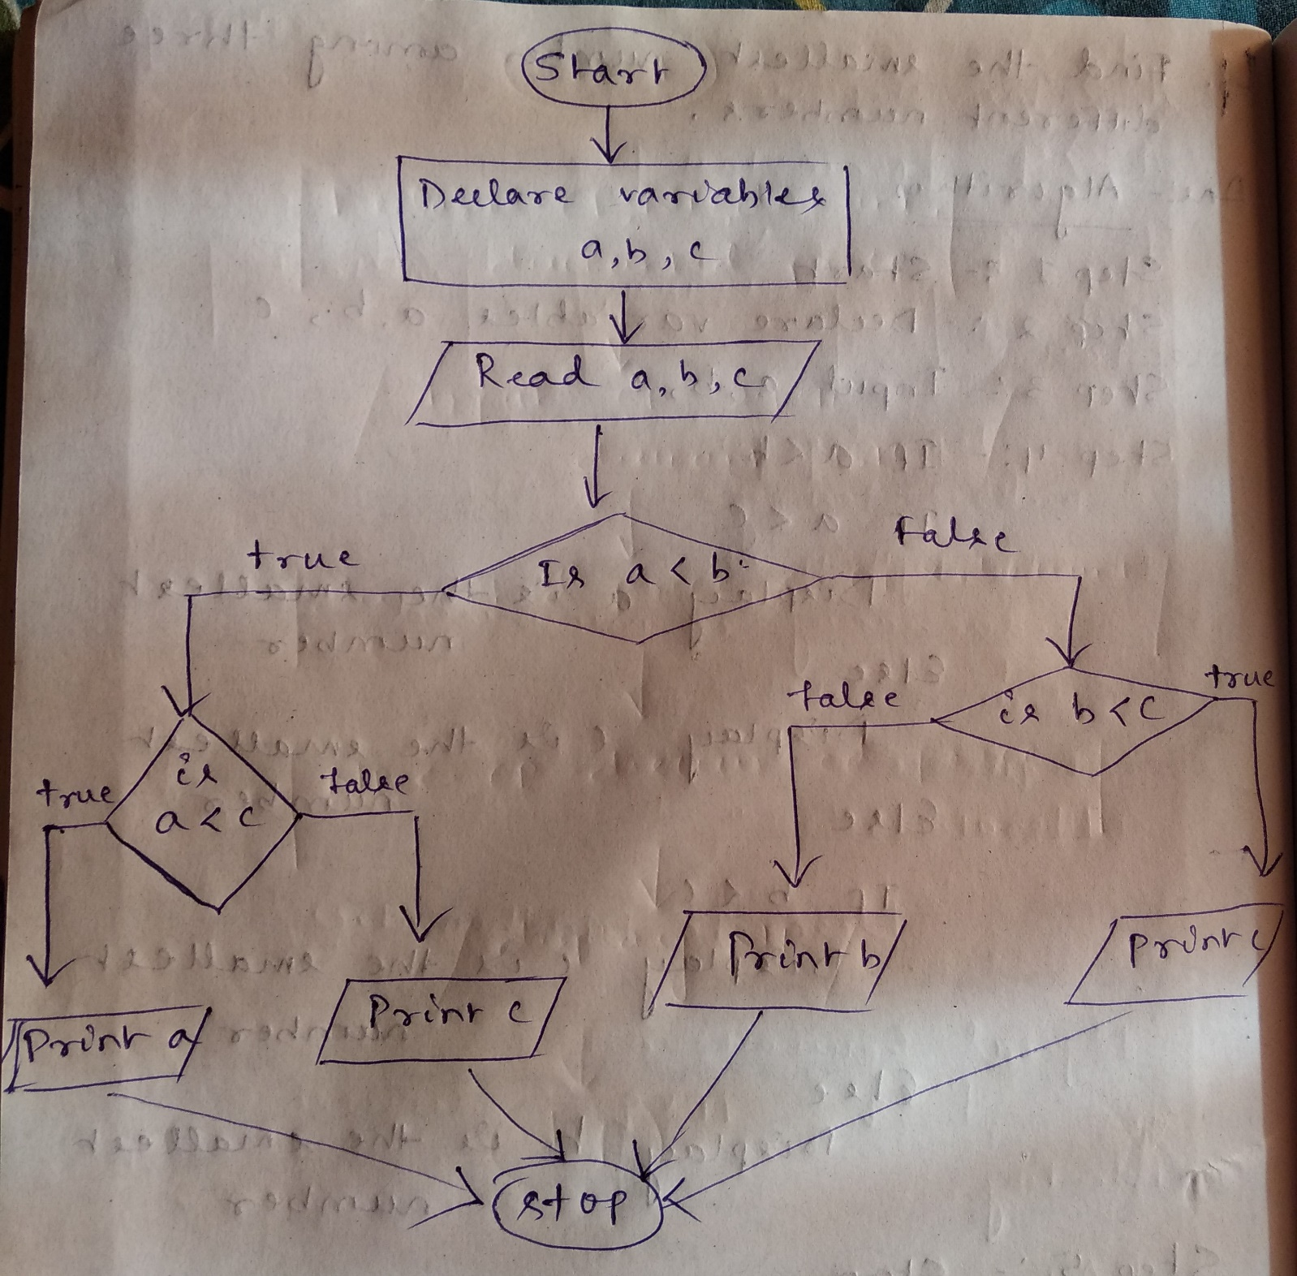

**Q5**. Find the Roots of a quadratic equation ax2+ bx + c = 0

Ans - Algorithm & flowchart

Step 1: Start

Step 2: Declare a, b, c, D, r1, r2

Step 3: Input a, b, c

Step 4: D = (b*b - 4*a*c)

Step 5: r1 = (-b+D)/2*a

r2 = (-b-D)/2*a

Step 6: Display r1, r2

Step 7: Stop

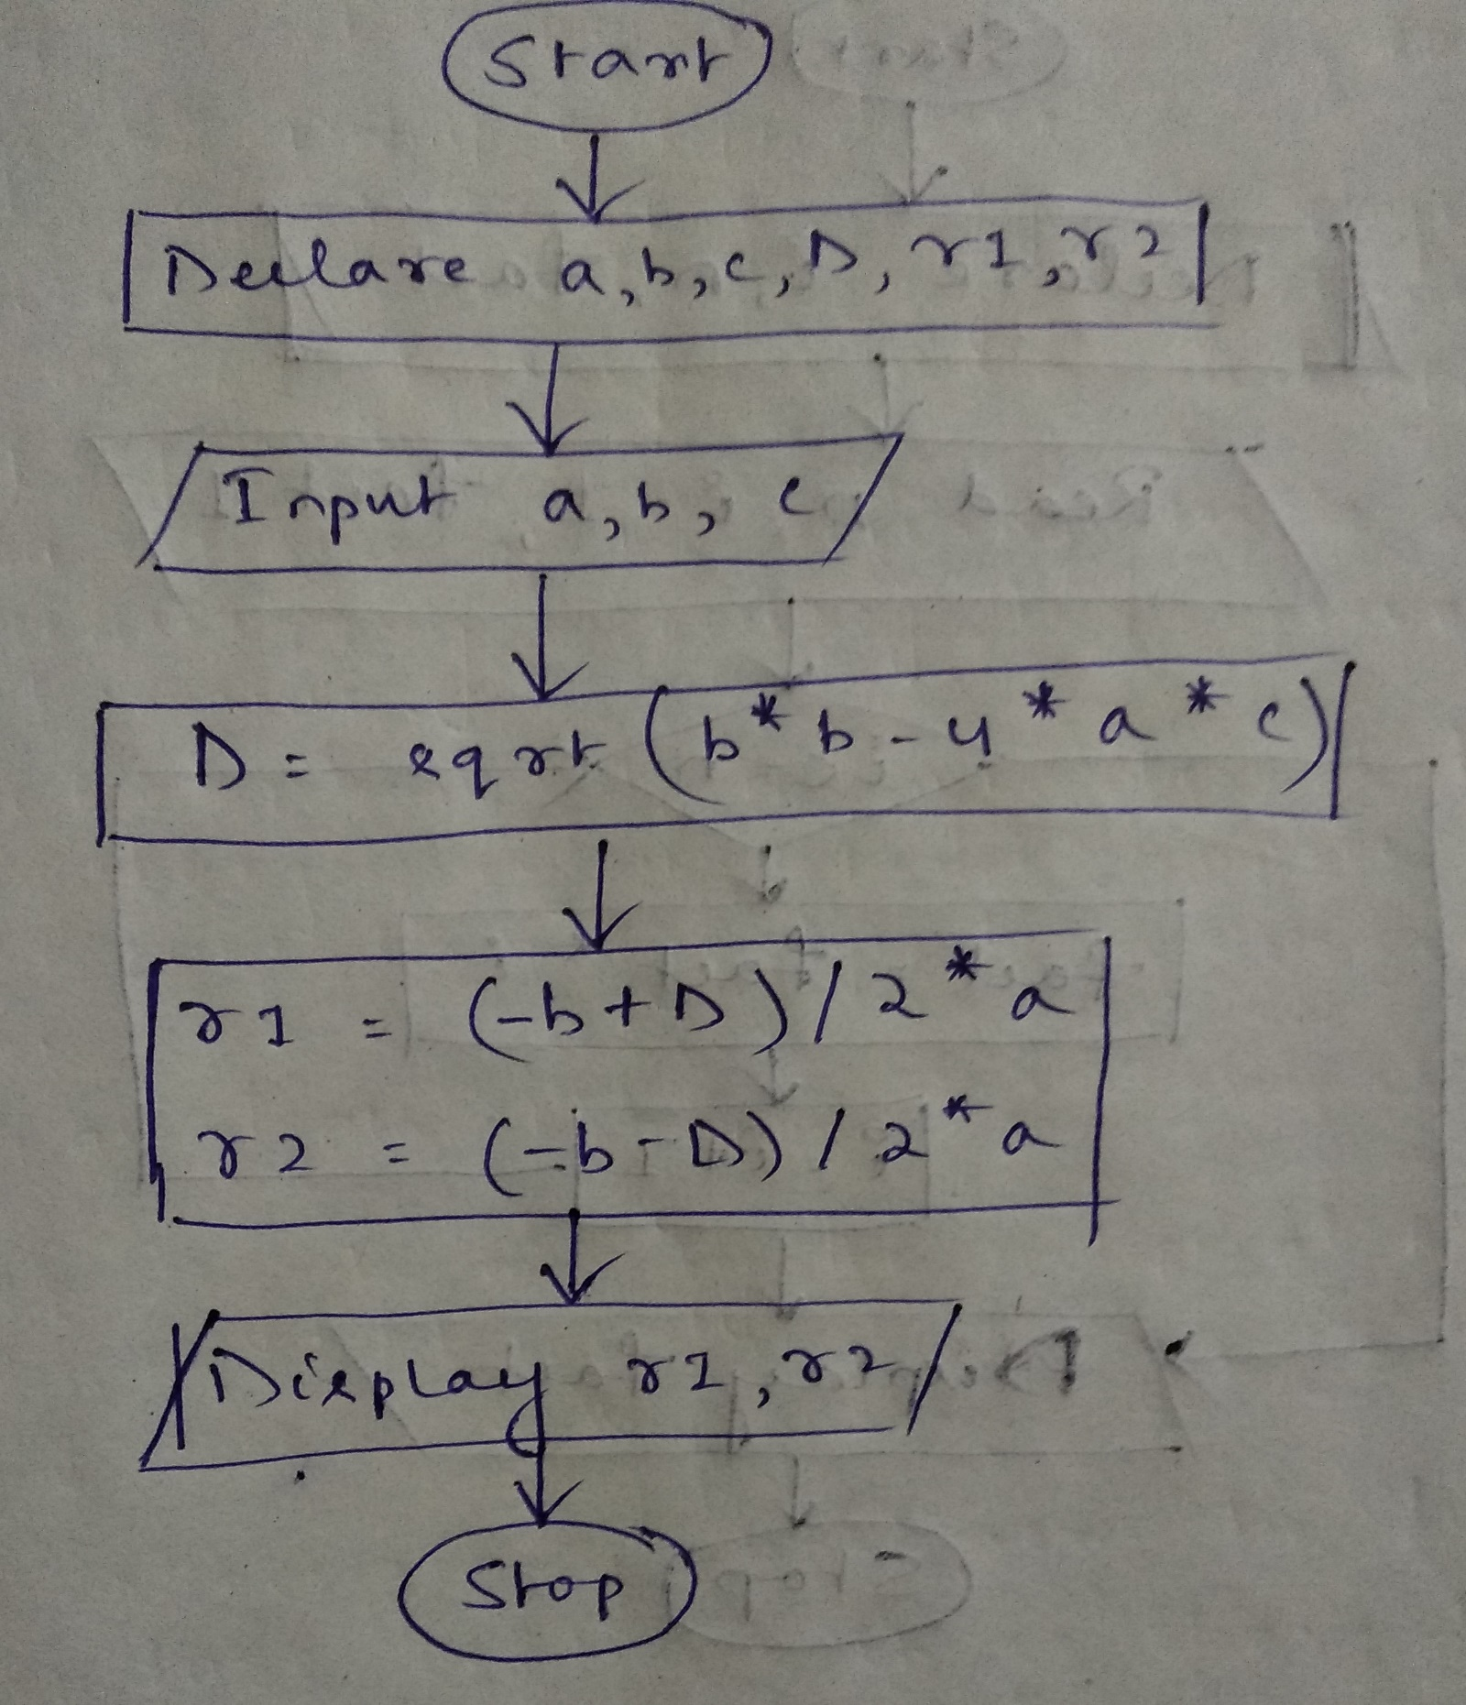

**Q6**. Find the factorial of a given number

Ans - Algorithm & flowchart

Step 1: Start

Step 2: Declare variables i, n, fact

Step 3: Read n, i=1, fact=1

Step 4: Initialize counter variable i to 1 and fact to 1

Step 5: if i <= n go to step 6Q otherwise goto step 8

Step 6: calculate fact = fact * i

Step 7: increment counter variable i and goto step 5

Step 8: Display fact.

Step 9: Stop

